**Adit Kulkarni**

**Web Technologies – Development Project 1**

**MSIS 517 L**

**1. Design Diagram –**

*Association with Charitable Organizations*

*Sports*

*Achievements, Awards & Certifications*

*Education*

*Experience*

*Adit Kulkarni Website*

*((Homepage)*

*Co-curricular*

*Professional Summary*

*Contact Me*

**AK**

**2. Description of the pages –**

In this project I am developing four pages of the above given design diagram.

a. AditKulkarniWebsite_HomePage – This is the home page of the website which gives some background about myself.

b. Professional – This page gives a brief overview of my Professional summary, also this page explains my skills set using a CSS Table, at the end of this page there is a link to download my resume.

c. Co-Curricular – This page gives information of my co-curricular activities like sports etc.

d. Contact me – This page gives my contact information, there is a button on this page which displays contact details on clicking it.

**3. Screen shots -**

Home Page Screen shots

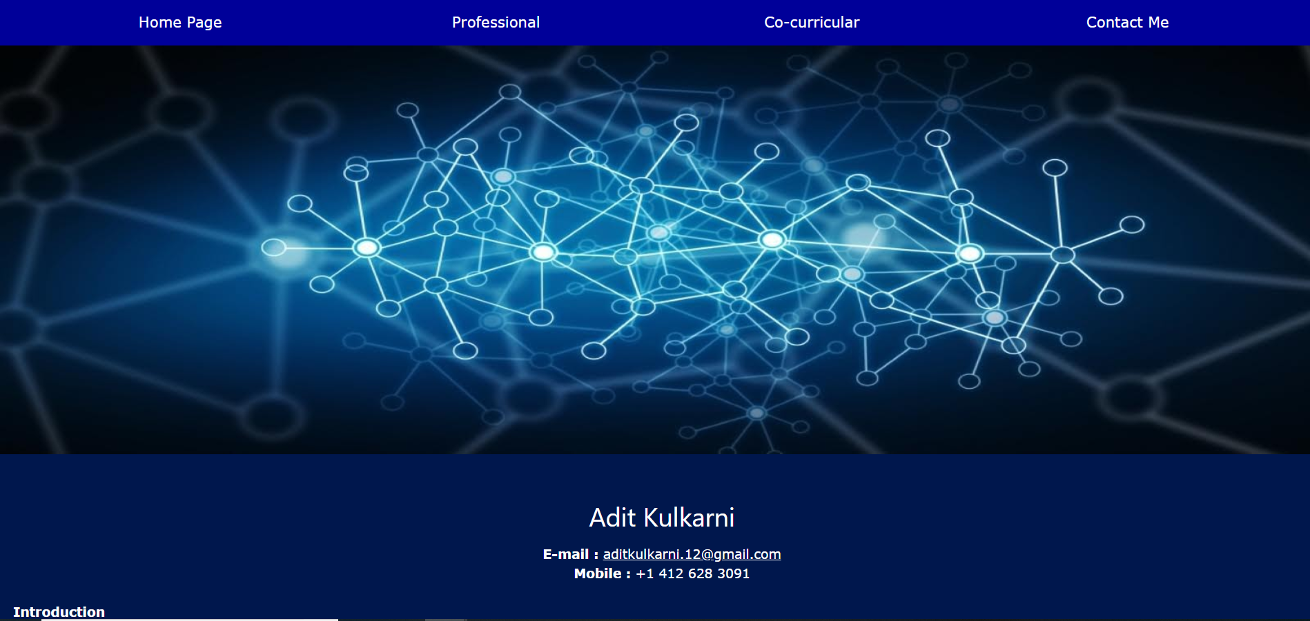

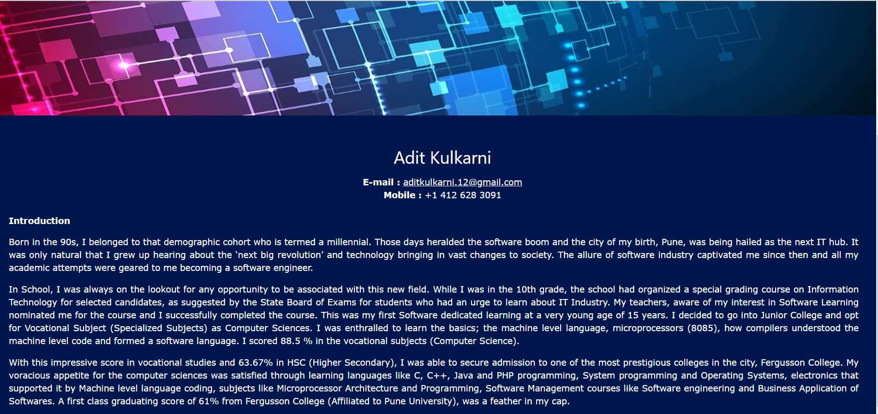

Professional Summary Screenshots

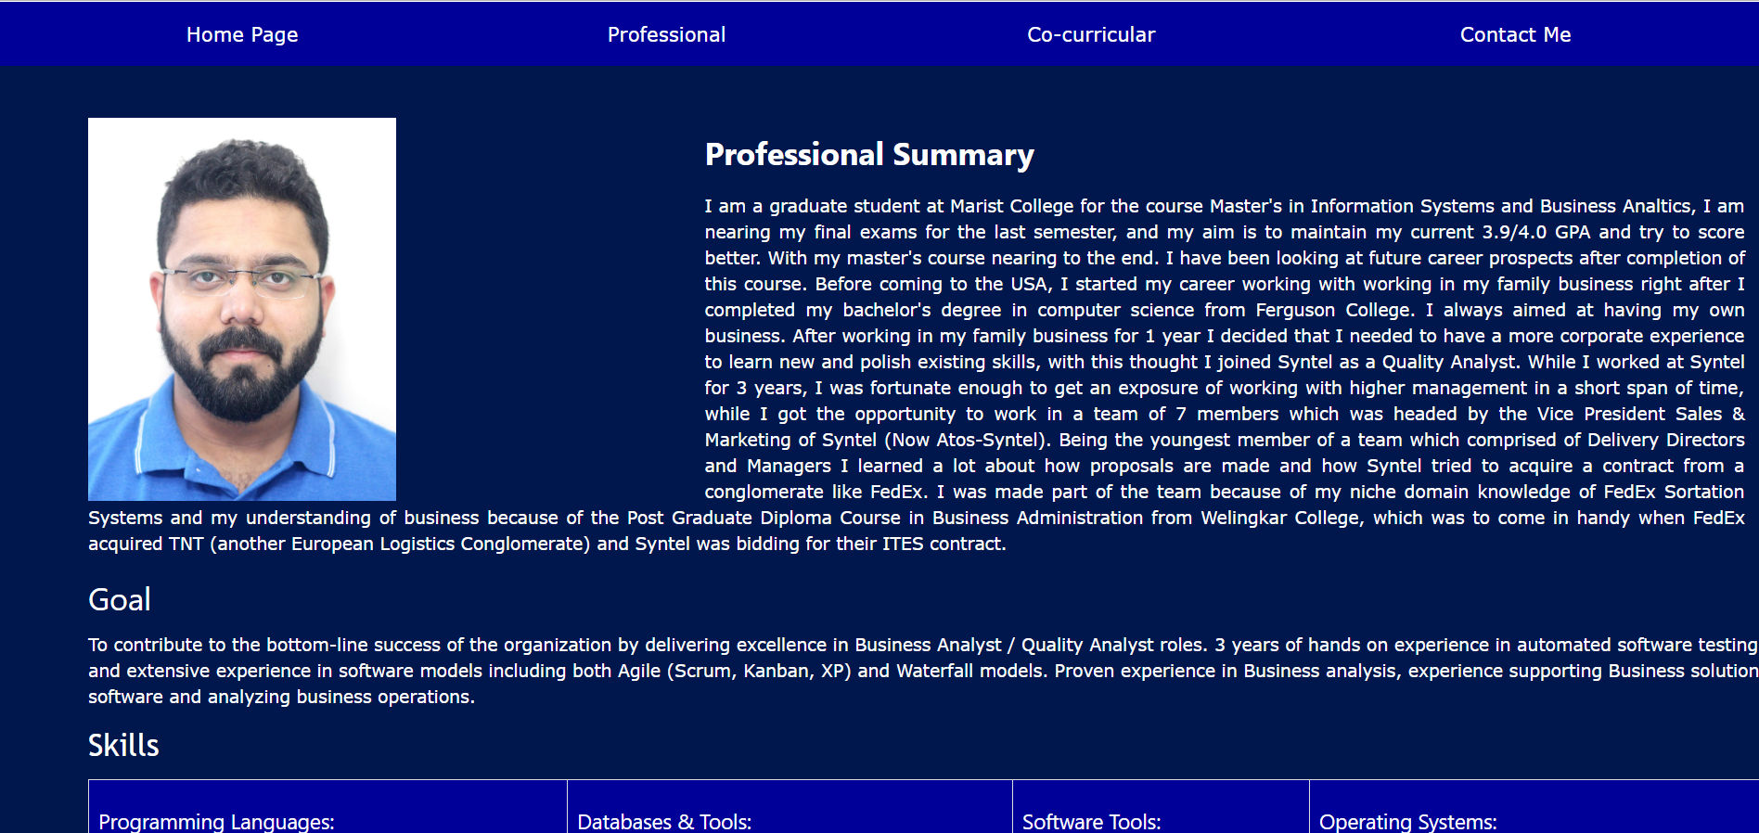

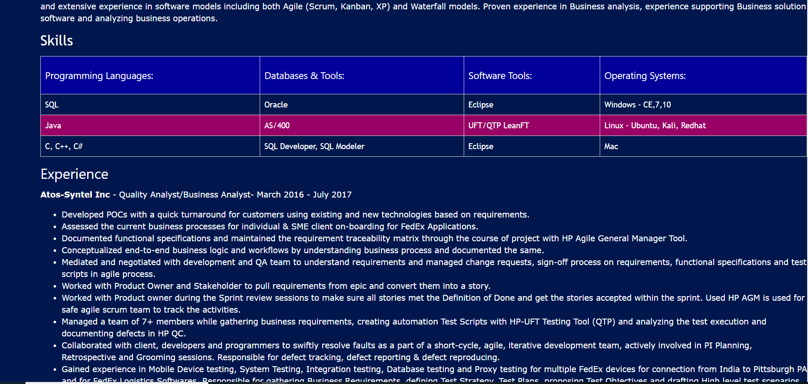

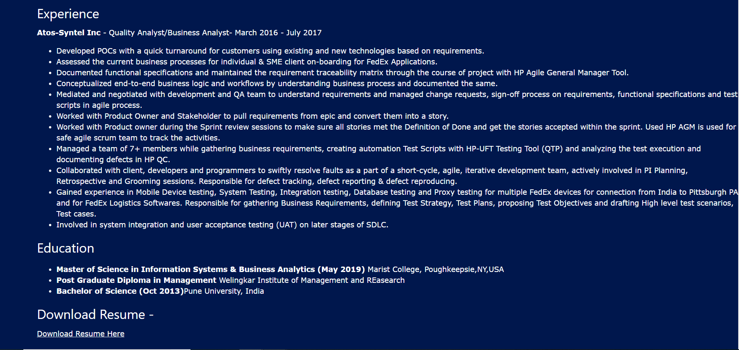

Co-curricular Screenshots

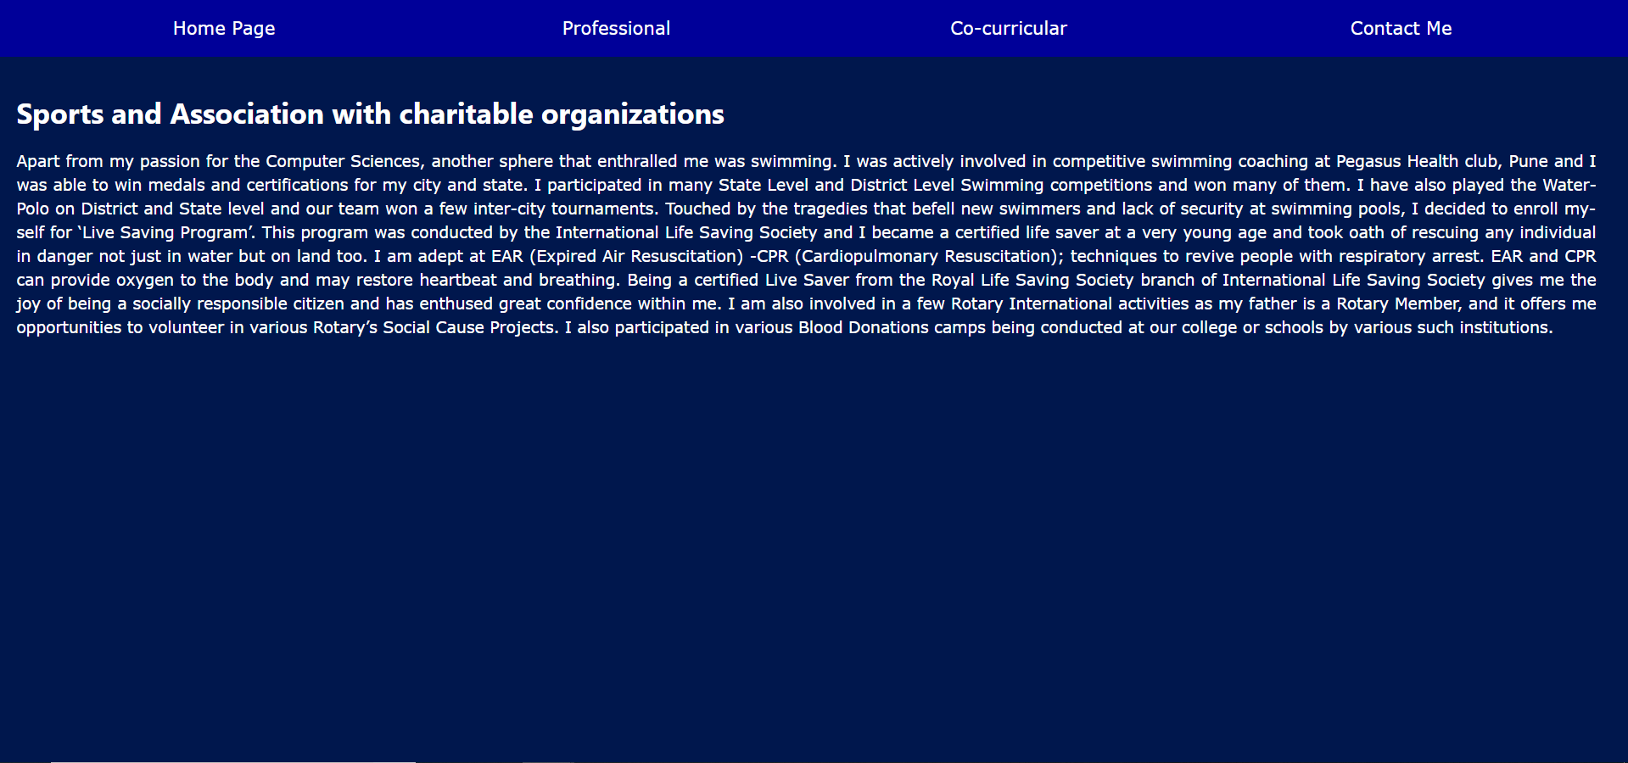

Contact Me Screenshot

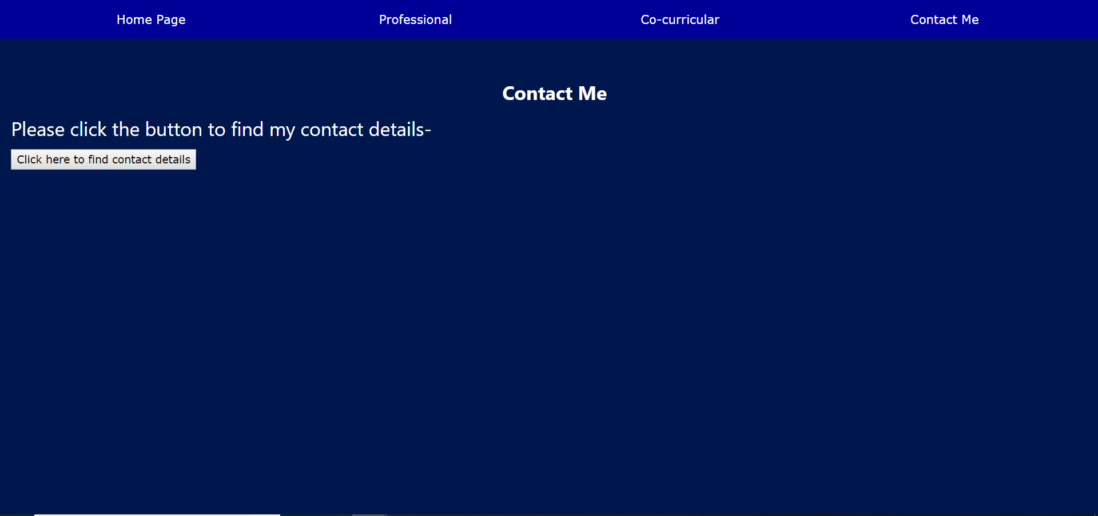

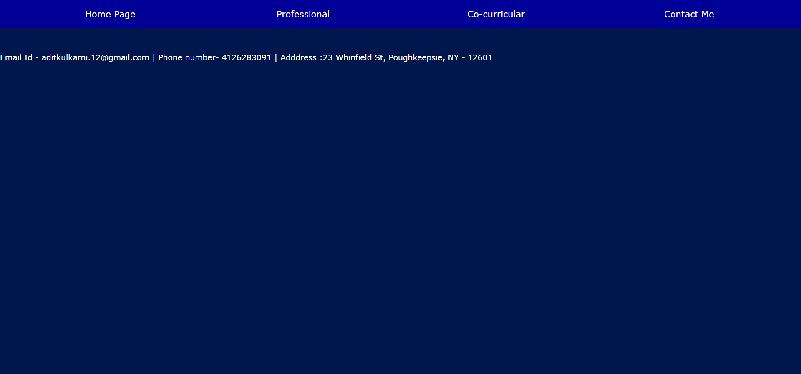

**GitHub Link** - <https://github.com/Aditkulkarni/Web-Technologies.git>